*e*

*nabling tomorrow’s technologies™*

355 South Technology Drive, Central Islip, New York 11722 | T 631.981.7081 | F 631.981.7095 |

**Part/Drawing Tracker Searching & Filtering Guide**

To search for a part/drawing:

1.

Click on the tab labeled

**Search**

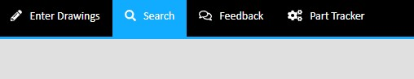

1. Click on the textbox at the **top right** of the screen above the table



1. Enter any piece of information that you wish to find or filter the results to. Any data that is in the table can be used to filter results. This means you can search by location, part/drawing number, employee, or anything else that is in the table. You do not need to press enter; the search will dynamically update as you type.



1. In order to filter results by more than one term, you need to put a space between the two terms you are searching for. This can be done for any information that is available, for any amount of search terms. For example, if you want to find a part that was scanned in at the location “Quality Control” by the employee “John Doe”, all you need to type in the search bar is “Quality Control John Doe”. You can even enter in just a part of the name, it will still automatically find what you are looking for as long as part of your search terms exist in a certain entry. This means that you can just search for “Quality John” and find the same results.
2. You can also order the results by any of the columns. Do this by clicking on the title of the column you wish to sort by.